# 4 Basic use

## 4.1 Internet

### 4.1.1 Web browser

* MX Linux comes with the popular browser **Firefox** installed, which has a large set of add-ons to augment the user’s experience.

[Firefox home page](https://www.mozilla.org/)

[Firefox add-ons](https://addons.mozilla.org/en-US/firefox/)

* Upgrades of Firefox come through the MX Linux repos, and are usually available to users within 24 hours of release. For direct download, see Section 5.5.5.
* Localization files for Firefox can be installed easily with MX Package Installer.
* Firefox has a sync service that facilitates transferring bookmarks, cookies, etc. from an existing Firefox installation.
* Other browsers are available for easy download and installation via the MX Package Installer. Check the [MX/antiX Wiki](https://mxlinux.org/wiki/applications/) for configuration tips and tricks.

### 4.1.2 Email

* [**Thunderbird**](https://www.mozilla.org/thunderbird/) is installed by default in MX Linux. This popular email client integrates well with Google Calendar and Google Contacts. The most recent versions available can be found with the MX Package Installer > MX Test Repo.
* Localization files for Thunderbird can be installed easily with MX Package Installer.
* For help with links no longer opening a browser, consult [the MX/antiX Wiki](https://mxlinux.org/wiki/applications/thunderbird/).
* Other lightweight email clients are available from the MX Package Installer.

### 4.1.3 Chat

* HexChat. This IRC chat program is installed by default in MX Linux, and makes the exchange of text messages easy for the user.

[HexChat home page](https://hexchat.github.io/)

* Pidgin. This graphical, modular instant messaging client is capable of using multiple networks at once. MX Package Installer.

[Pidgin home page](http://pidgin.im/)

#### Video Chat

* [Zoom](https://zoom.us/). This very popular video chat program is cross-platform and can be installed on MX Linux without problem using the **MX Package Installer > Messaging**. It integrates automatically with PulseAudio, which is installed by default.
* Gmail has a talk function built in, now called [**Duo**](https://duo.google.com/). See Section 4.10.6
* Skype. A popular proprietary program for instant messaging as well as voice and video chat.

[Skype home page](https://www.skype.com/en/)

Troubleshooting

* If your voice is not being picked up even after you use the app’s own tools, try this:
  + Sign into your video chat app, click on Options and go to the Sound Devices tab.
  + Click on the button to start a test call. While the call is going on, open PulseAudio Volume Control and go to the Recording tab.
  + Still while the test call is going on - change the Skype to the Webcam microphone.

## 4.2 Multimedia

Listed here are some of the many multimedia applications available in MX Linux. Advanced professional applications also exist, and can be found through targeted searches in Synaptic.

### **4.2.1 Music**

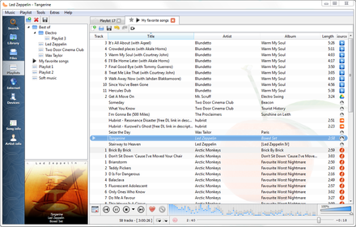

***Figure 4-1: Playing a CD track with Clementine***

* Players
  + Clementine. A modern music player and library organizer that can play every source from a CD to a Cloud Service. Installed by default.

[Clementine home page](https://www.clementine-player.org/)

* + Audacious. A full-featured music player and manager. MX Package Installer.

[Audacious home page](http://audacious-media-player.org/)

* + DeaDBeeF. A lightweight player with a small memory footprint, robust set of basic features, and a focus on music playback. MX Package Installer.

[DeaDBeeF home page](http://deadbeef.sourceforge.net/)

* Rippers and editors
  + Asunder. A graphical Audio CD ripper and encoder that can be used to save tracks from Audio CDs. Installed by default.

[Asunder home page](http://littlesvr.ca/asunder/)

* + EasyTAG. A simple application for viewing and editing tags in audio files.

[EasyTAG home page](https://wiki.gnome.org/Apps/EasyTAG)

### **4.2.2 Video**

[UPDATE: Netflix on 32 bit Linux](https://www.youtube.com/watch?v=fY_PqMJ5kG4)

* Players
  + VLC. Plays a large range of video and audio formats, DVDs, VCDs, podcasts, and multimedia streams from various network sources. Installed by default.

[VLC home page](http://www.videolan.org/vlc/)

* + A YouTube Browser for SM Player is installed by default.

[SMplayer home page](http://smplayer.sourceforge.net/)

* + Netflix. Desktop capability of streaming Netflix is available for Firefox and Google Chrome.

[Netflix home page](https://www.netflix.com/us/)

***Figure 4-2: Running desktop Netflix in Google Chrome***

* Rippers and editors
  + HandBrake. A video ripper that is easy to use, fast and simple. MX Package Installer.

[HandBrake home page](https://handbrake.fr/)

* + DeVeDe. This utility automatically converts material to formats compatible with audio CD and video DVD standards.

[DeVeDe home page](http://www.rastersoft.com/programas/devede.html)

* + DVDStyler. Another good authoring utility. MX Package Installer.

[DVDStyler home page](http://www.dvdstyler.org/en/)

* + OpenShot. A simple-to-use and feature-rich video editor. MX Package Installer.

[OpenShot home page](http://www.openshot.org/)

### 4.2.3 Photos

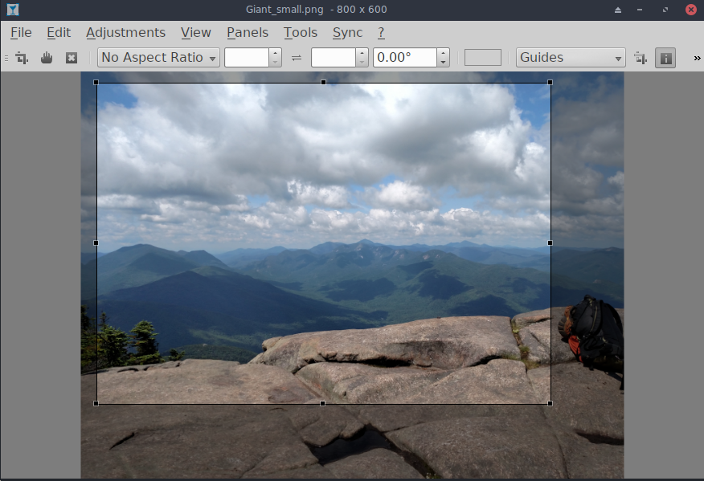

***Figure 4-3: Using the crop tool in Nomacs***

* Nomacs. A fast and powerful image viewer installed by default.

[Nomacs home page](https://nomacs.org/)

* Mirage. This speedy application is easy to use and allows you to view and edit digital photos. MX Package Installer.

[Mirage project page](http://sourceforge.net/projects/mirageiv.berlios/)

* Fotoxx. This fast application allows easy photo editing and collection management while serving the needs of serious photographers. MX Package Installer > MX Test Repo.

[Fotoxx home page](http://www.kornelix.net/fotoxx/fotoxx.html)

* GIMP. The premier image manipulation package for Linux. Help (**gimp-help**) must be installed separately, and is available in many languages. Basic package installed by default, full available from MX Package Installer.

[GIMP home page](http://www.gimp.org/)

* gThumb. an image viewer and browser from the GNOME Developers that also includes an importer tool for transferring photos from cameras. Default in MX-21.

[gThumb Wiki](http://gthumb.sourceforge.net/features.html)

* LazPaint, a cross-platform lightweight image editor with raster and vectorial layers. Default in MX-21.

[LazPaint documentation](https://wiki.freepascal.org/LazPaint)

* Gwenview, the KDE project image viewer

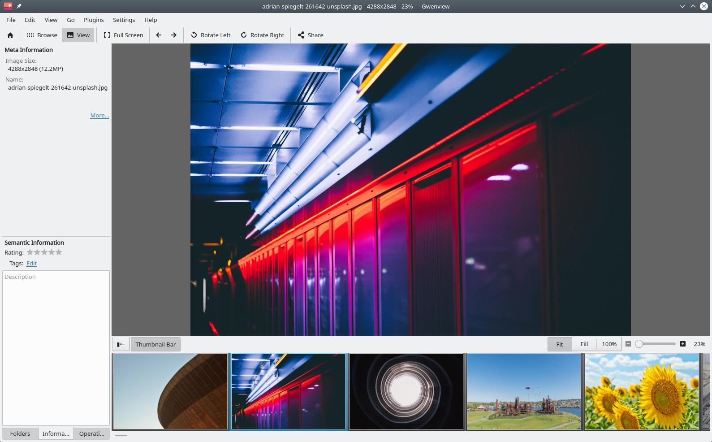

***Figure 4-4: Gwenview***

### 4.2.4 Screencasting

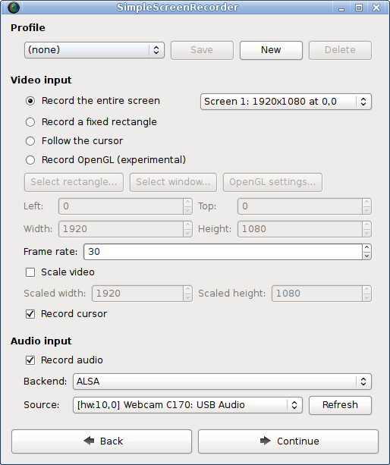

***Figure 4-5: Main screen of SimpleScreenRecorder***

* Simple ScreenRecorder. A simple but powerful program to record programs and games. MX Package Installer.

[SimpleScreenRecorder home page](http://www.maartenbaert.be/simplescreenrecorder/)

* RecordMyDesktop. Captures audio-video data of a linux desktop session. MX Package Installer.

[RecordMyDesktop home page](http://recordmydesktop.sourceforge.net/about.php).

### 4.2.5 Illustrations

* mtPaint. An easily learned application for creating pixel art and manipulating digital photos.

[mtPaint home page](http://mtpaint.sourceforge.net/)

* LibreOffice Draw. Diagrams, drawings and pictures can be created and modified with this application.

[LO Draw home page](http://www.libreoffice.org/discover/draw/)

* Inkscape. This illustration editor has everything needed to create professional-quality computer art. MX Package Installer.

[Inkscape home page](https://inkscape.org/en/)

## **4.3 Office**

### **4.3.1 Office suites**

***4.3.1.1 On the desktop***

LibreOffice

MX Linux comes with a great free office suite called LibreOffice, which is the Linux equivalent and near drop-in replacement for Microsoft Office®. The suite is available under **Application Menu > Office > LibreOffice**. LibreOffice supports the .docx, .xlsx and .pptx file formats of Microsoft Office 2007 and above.

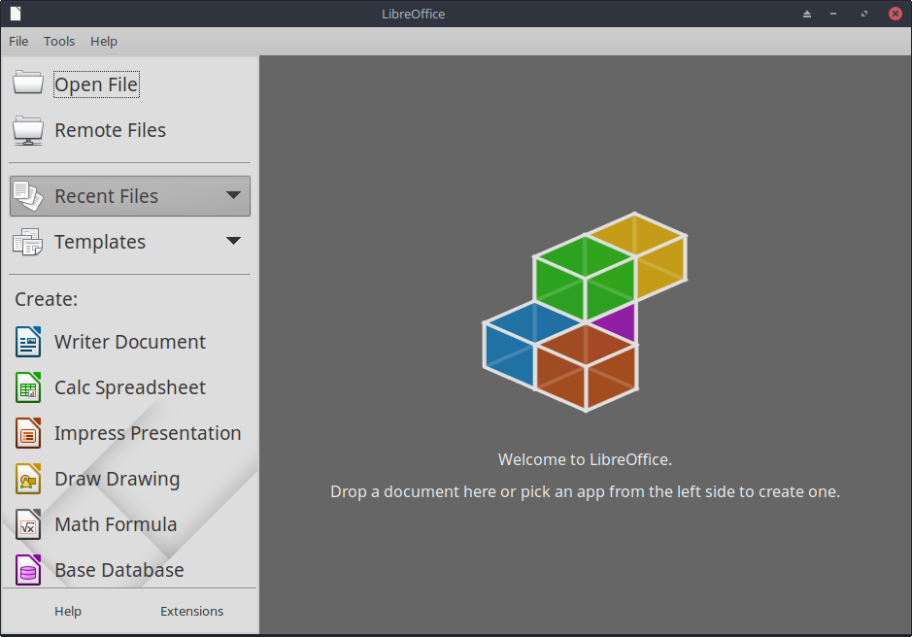

***Figure 4-6: Main dashboard in LibreOffice 6***

* The latest version available in the default repos is installed by default.
  + Word Processor: LibreOffice Writer. An advanced word processor compatible with .doc and .docx files.
  + Spreadsheet: LibreOffice Calc. An advanced spreadsheet compatible with .xls and .xlsx files.
  + Presentation: LibreOffice Impress. Presentations, compatible with .ppt and .pptx files.
  + Draw: LibreOffice Draw. Used to create graphics and diagrams.
  + Math: LibreOffice Math. Used for for mathematical equations.
  + Base: LibreOffice Base. Used to create and manipulate databases. If using this application to create or use databases in the native LibreOffice format, you must also install **libreoffice-sdbc-hsqldb** and **libreoffice-base-drivers** matched to version.
* Users can get more recent versions by a number of different methods:
  + Download directly from the LibreOffice. See [the MX/antiX Wiki](https://mxlinux.org/wiki/applications/libreoffice/) for details.
  + Download from MX Package Installer, Backports tab.
  + Download the flatpak (MX Package Installer) or the [appimage](https://www.libreoffice.org/download/appimage/).

LINKS

* [LibreOffice home page](https://www.libreoffice.org/).
* [MX/antiX Wiki](https://mxlinux.org/wiki/applications/libreoffice).

Other desktop suites are available as well.

* [Softmaker Free Office](https://www.freeoffice.com/) -- MX Package Installer: Popular applications
* [Calligra Suite](https://www.calligra.org/) (part of the KDE project) -- MX Package Installer: Test Repo

***4.3.1.2 In the cloud***

*Google*

Google’s [Docs and Office Suite](https://www.google.com/docs/about/) (the latter requires subscription) offers excellent online applications that include three standard office components: Docs, Sheets and Slides. It is easy to share files and the export options are very handy.

*Microsoft*

Microsoft products are not FOSS, yet many users need or want to have access to the, especially for business, institutional and other such contexts. Although Microsoft Office suite applications can't be natively installed under Linux, Microsoft's [Office365](https://www.office.com/) (paid service) or [On-line Office](https://products.office.com/en-us/office-online/documents-spreadsheets-presentations-office-online) (free) are just regular web pages that run fine inside any modern browser on MX Linux. Details in [the MX/antiX Wiki](https://mxlinux.org/wiki/applications/microsoft-office/).

*Other options*

* [OnlyOffice](https://www.onlyoffice.com/) (paid service for enterprises)

### 4.3.2 Office finances

* GnuCash. Financial software for office use. It is easy to learn, and allows you to track bank accounts, stocks, income and expenses. Can import data in QIF, QFX and other formats, and supports double entry accounting. MX Package Installer. The Help package (**gnucash-docs**) needs to be installed separately.
* [GnuCash home page](http://gnucash.org/)

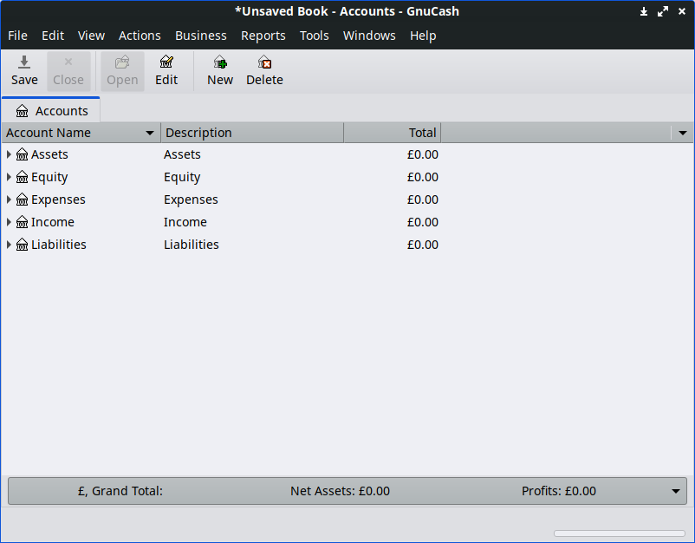

***Figure 4-7: New account in GnuCash***

### 4.3.3 PDF

* QPDFview. A fast and lightweight viewer that includes a number of basic tools. Installed by default.

[QpdfView home page](https://launchpad.net/qpdfview)

* Okular, the KDE project PDF and document reader

[Okular documentation](https://okular.kde.org/)

* Adobe Reader for Linux offers greater functionality (such as commenting or form filling). MX Package Installer (under Office).

[Adobe Reader home page](http://www.adobe.com/products/reader.html)

* PDFShuffler makes simple the reordering, deleting and adding of PDF pages. Installed by default.

[PDFShuffler home page](http://pdfshuffler.sourceforge.net/)

* gscan2pdf is a handy method of scanning documents to PDF in addition to serving general scanning needs. MX Package Installer ([MX/antix Wiki](https://mxlinux.org/wiki/applications/gscan2pdf)).

[gscan2pdf home page](http://gscan2pdf.sourceforge.net/)

* SimpleScan is minimal scan software that works very well for everyday tasks. Installed by default on MX-21.

[SimpleScan home page](https://gitlab.gnome.org/GNOME/simple-scan)

* For other functions (e.g., creating a PDF form), see [MX/antiX Wiki](https://mxlinux.org/wiki/applications/pdf).

### 4.3.4 Desktop publication

* Scribus. Professional page layout that produces press-ready output. Available via MX Package Installer.

[Scribus home page](https://www.scribus.net/)

### 4.3.5 Project time tracker

* Kapow punch clock. Simple but feature-rich app to record project time.

[Kapow home page](https://gottcode.org/kapow/)

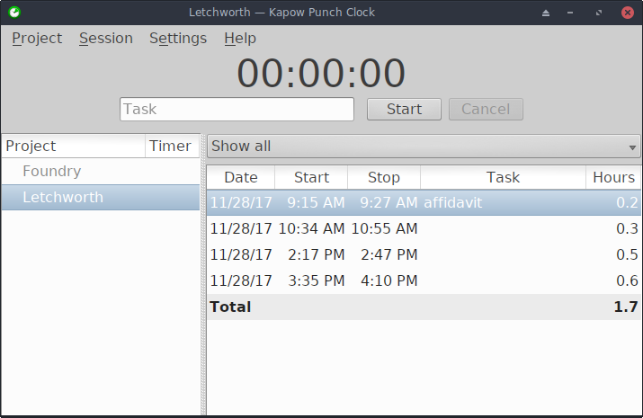

***Figure 4.8 Kapow set to track work on a project***

* [Other options](https://www.linuxlinks.com/timetracking/)

### 4.3.6 Video meeting and remote desktop

* [AnyDesk](https://anydesk.com/en). Allows easy remote access. MX Package Installer, along with other options.
* TeamViewer. Cross-platform application for Remote Support and Online Meetings. Free for private use. MX Package Installer.

[TeamViewer home page](https://www.teamviewer.us/)

## 4.4 Home

### 4.4.1 Finances

* HomeBank. Easy management of your personal accounting, budget and finance.

[HomeBank home page](http://homebank.free.fr/en/)

* Grisbi is very useful for the home. It can import QIF/QFX files, and has an intuitive interface. Perhaps better suited to banks outside the US.

[Grisbi home page](http://www.grisbi.org/)

### 4.4.2 Media Center

* Plex Mediaserver. Lets you bring together all your media and view it in one place. MX Package Installer.

[Plex home page](https://www.plex.tv/)

* Kodi Entertainment Center (formerly XBMC) allows users to play and view videos, music, podcasts, and media files from local and network storage media. MX Package Installer.

[Kodi home page](http://kodi.tv/)

### 4.4.3 Organization

* Notes. This handy Xfce plugin (**xfce4-notes-plugin**) allows you to create and organize sticky notes for your desktop.

[Notes home page](http://goodies.xfce.org/projects/panel-plugins/xfce4-notes-plugin)

* KDE Pim Application, a suite of applications to manage personal information.

<https://community.kde.org/KDE_PIM>

* Osmo. Nice compact application that includes calendar, tasks, contacts and notes.

[Osmo home page](http://clayo.org/osmo/)

***Figure 4-9: The personal information manager Osmo***

## 4.5 Security

### 4.5.1 Firewall

* Gufw. A personal firewall configuration utility that makes it easier for the user to configure the firewall. Installed by default.

[Gufw home page](http://gufw.org/)

[Wikipedia: Personal firewall](http://en.wikipedia.org/wiki/Personal_firewall)

### 4.5.2 Antivirus

* ClamAV. Useful to stop Linux users from unknowingly passing virus-infected emails and other documents to susceptible Windows users.

[ClamAV home page](https://sourceforge.net/projects/clamav/)

### 4.5.3 AntiRootkit

* chkrootkit. This application scans systems for known and unknown rootkits, backdoors, sniffers and exploits.

[chkrootkit home page](http://www.chkrootkit.org/)

### 4.5.4 Password protection

* Passwords and Keys. A password and key manager installed by default. Details on usage in [the MX/antiX Wiki](https://mxlinux.org/wiki/applications/passwords-and-keys).

[Passwords and Keys help](https://help.gnome.org/users/seahorse/stable/)

* KeePassX. A password manager or safe that helps you to manage your passwords in a secure way. MX Package Installer.

[KeePassX home page](http://www.keepassx.org/)

### 4.5.5 Web access

* Most modern browsers have add-ons that permit easy web filtering.
* FoxFilter is a well-established example that installs on Firefox, Chrome and Opera.

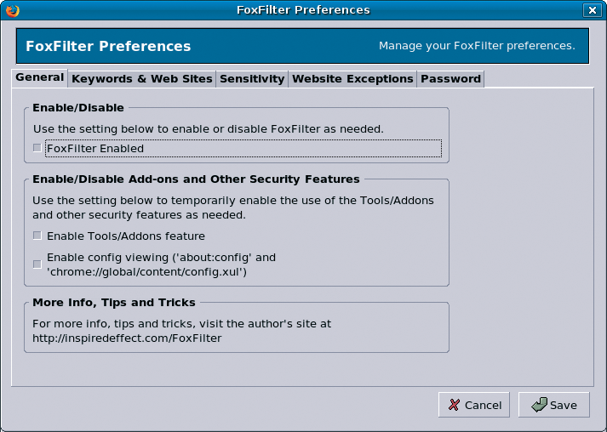

***Figure 4-10: The preferences tab for FoxFilter***

## 4.6 Accessibility

Various open-source utilities exist for MX Linux users with disabilities.

* On-screen keyboard. Onboard is installed by default, and Florence is in the repos.
* Xfce. Click Application Menu > Settings > Accessibility, and tick Enable Assistive Technologies. Change the available options to suit your liking.

[Xfce4 documentation: Accessibility](http://docs.xfce.org/xfce/xfce4-settings/accessibility)

* KDE maintains a large collection of accessibility aids.

[KDE Accessibility applications](https://userbase.kde.org/Applications/Accessibility)

* Debian. Many other tools are available within Debian itself.

[Debian Wiki](https://wiki.debian.org/accessibility)

## 4.7 System

### 4.7.1 Root privileges

There are two common commands to obtain root (AKA administrator, superuser) privileges that you need to make system changes (e.g., installing software) using a terminal.

* su: requires the root password and grants privileges for entire terminal session
* sudo: requires your user password and grants privileges for a short time period

In other words, su lets you switch user so that you’re actually logged in as root, while sudo lets you run commands in your own user account with root privileges. Also, su uses the environment (user-specific configuration) of the user root, while sudo allows root-level changes but keeps the environment of the user issuing the command. Starting with MX-21, MX Linux uses by default sudo, which Forum members will generally recommend as well.

The user can decide whether to use “Root” or “User” on the “Other” tab of MX Tweak.

MORE: click Application Menu > enter “#su” or “#sudo” (without the quotes) in the search space and return to see the detailed man pages.

#### Running a root application

Some applications that can be found in the Application Menu require that the user have root privileges: gparted, lightdm gtk+ greeter, etc. Depending on how the launch command is written, the dialog box that pops up may show that root access will be stored (default setting) for as long as your session lasts (i.e., until you log out).

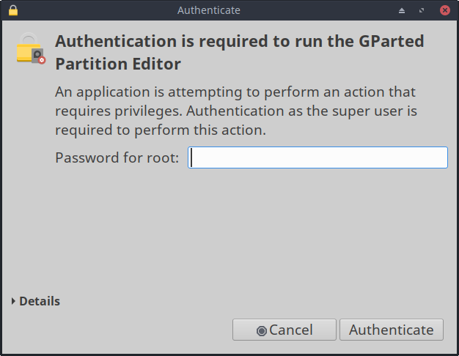

***Figure 4-11: Dialog box when the command pkexec is used with no storage of root password***

### 4.7.2 Get hardware specs

* Click **Application Menu > System > System Profiler and Benchmark** for a nice graphic display that includes the results of various tests.
* Click **Application Menu > MX Tools > Quick System Info**. The output is automatically copied to the clipboard, and can also be pasted into a Forum post complete with code tags.

See Section 6.5 for the many other features of inxi.

### 4.7.3 Create symbolic links

A symbolic link (also soft link or symlink) is a special kind of file that points to another file or folder, much like a shortcut in Windows or an alias in Macintosh. A symbolic link does not contain any actual data (as a hard link does), it just points to another location somewhere in the system.

There are two ways to create a symlink: File Manager or the command line.

* Thunar
  + Navigate to the file or folder (target of the link) that you want to point to from another location or under another name
  + Right-click what you want to link > Create Symlink, and a symlink is created where you currently are
  + Right-click the new symlink > Cut
  + Navigate to where you want the link to be, right-click an open area> Paste. Change if desired the link name.
* dolphin/KDE-plasma
* Use Create New > Basic Link to File or Directory
* Command line: Open a terminal and type:

*ln -s TargetFileOrFolder LinkName*

* + For example, to symlink a file named “foo” in your Downloads folder to your Documents folder, enter this:

*ln -s ~/Downloads/foo ~/Documents/foo*

### **4.7.4 Find files and folders**

#### GUI

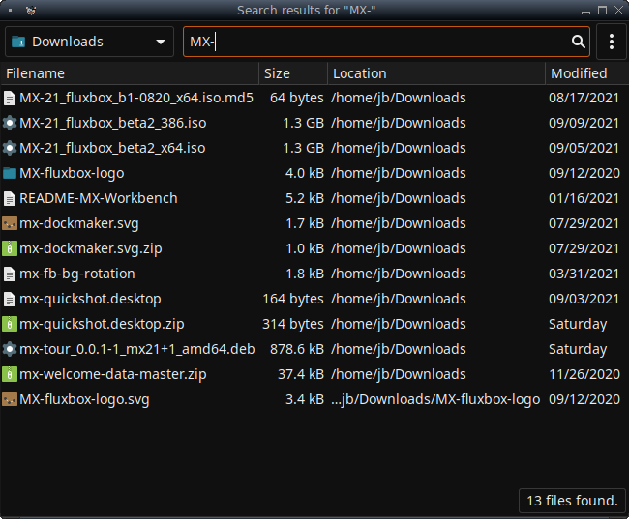

***Figure 4-12: Search screen of Catfish* looking for “MX-” in the Downloads folder**

**Catfish** is installed by default in MX Linux Xfce, and can be launched from the **Application Menu > Accessories,** or simply by starting to type “search” in the top search entry field. It is also integrated into Thunar so that the user can right-click a folder > Find files here.

[Catfish home page](http://www.twotoasts.de/index.php/catfish/)

KDE/plasma users can access the find dialog built into the dolphin file manager toolbar.

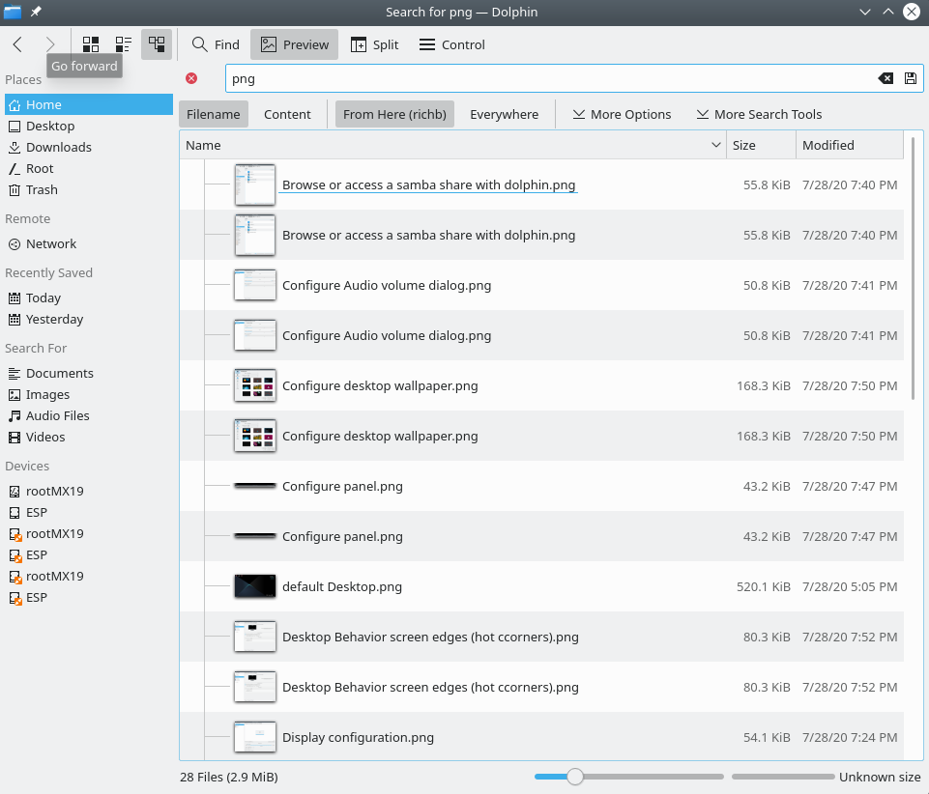

***Figure 4-13: dolphin Find search results***

Other more advanced search software is available in the repos such as [recoll](https://www.lesbonscomptes.com/recoll/).

#### CLI

There are some very handy commands for use in a terminal.

* *locate*. For each given pattern, locate searches one or more databases of file names and displays the ones that contain the pattern. For example, typing:

*locate firefox*

will return an extremely long list with every single file that has the word “firefox” in its name or its path. This command is similar to [find](http://www.tecmint.com/35-practical-examples-of-linux-find-command/) and is best used when the exact file name is known.

[Locate examples](http://www.thegeekstuff.com/2012/03/locate-command-examples/)

* *whereis*. Another command-line tool, installed by default. For each given pattern, whereis searches one or more databases of file names and displays the file names that contain the pattern, but it ignores paths so the return list is much shorter. For example, typing:

*whereis firefox*

will return a much shorter list something like this:

firefox: /usr/bin/firefox /etc/firefox /usr/lib/firefox

/usr/bin/X11/firefox /usr/share/firefox /usr/share/man/man1/firefox.1.gz

[Whereis examples](http://www.cyberciti.biz/faq/unix-linux-whereis-command-examples-to-locate-binary/)

* *which*: Arguably the most convenient tool of all, this command attempts to identify the executable. For example, typing:

*which firefox*

returns a single item:

/usr/bin/firefox

[Which examples](http://www.thegeekstuff.com/2013/04/linux-which-whatis-whereis/)

### 4.7.5 Kill runaway programs

* Desktop
  1. Press **Ctrl-Alt-Esc** to change the cursor into an “x”. Click on any open screen to kill it, right-click to cancel. Be careful not to click on the desktop or your session will end abruptly.
  2. Xfce - Task Manager: **Application Menu > Favorites**, or click **Application Menu > System > Task Manager**. Select the process you want and right-click to stop, terminate or kill.
  3. KDE/plasma – **Application Menu > Favorites**, or click **Application Menu > System > System Monitor**
  4. A traditional tool is also available: click **Application Menu > System > Htop**, which brings up a terminal showing all running processes. Locate the program you want to stop, highlight it, press F9, then Return.
* Terminal: Press **Ctrl-C**, which will usually stop a program/command you started in a terminal session.
* If the above solutions don’t work, try these more extreme methods (listed in increasing severity).
  1. Restart X. Press **Ctrl-Alt-Bksp** to kill all session processes, leaving you back at the login screen. Any unsaved work will be lost.
  2. Use magic SysRq key (REISUB). Hold down the **Alt** key (sometimes only the left Alt key will work) along with the **SysRq** (can be also labeled **Print Screen** or **PrtScrn)** key with another hand, then slowly, without releasing Alt-SysRq, press the keys **R-E-I-S-U-B** one after the other. Hold down each key of the REISUB sequence for about 1 or 2 second before moving on to the next key; your system should shut down correctly and reboot. The purpose of this magic key is to go through several stages that nurse your system safely out of a failure of some sort, and often only the first 2 letters are sufficient. This is what happens when you go through the letters:
     + R - switch the keyboard mode. This is said to "Switch the keyboard from raw mode, the mode used by programs such as X11 and svgalib, to XLATE mode" (from [Wikipedia](https://en.wikipedia.org/wiki/Magic_SysRq_key)), but it is unsure if this would normally have any notable effect.
     + E - gracefully terminate all running programs. This sends the SIGTERM signal to all processes except init and thereby asks them to gracefully terminate, giving them a chance to tidy up and free their resources, save data, etc...
     + I - forcibly kill all running programs. This is similar to the E, but sends the SIGKILL signal to all processes except init, which kills them immediately and forcibly.
     + S - sync all disks and flush their caches. All your disks normally have a write cache, a piece of RAM where the system caches data it wants to save on the device, to speed the access up. Syncing tells the system to flush these caches now and perform all remaining writes. That way you do not lose any data that has already been cached but not been written yet, and it protects from leaving the file system in an inconsistent state.
     + U - unmount all disks and remount them read-only. This is again pretty unspectacular, it simply makes all mounted disks read-only to prevent any further (partial) writes.
     + B - reboot the system. This reboots the system. However, it does not perform a clean shutdown, but instead a hard reset.

[Wikipedia: REISUB](https://en.wikipedia.org/wiki/Magic_SysRq_key)

* 1. If nothing else works, hold down the power button of your computer for 10 seconds or so until it shuts down.

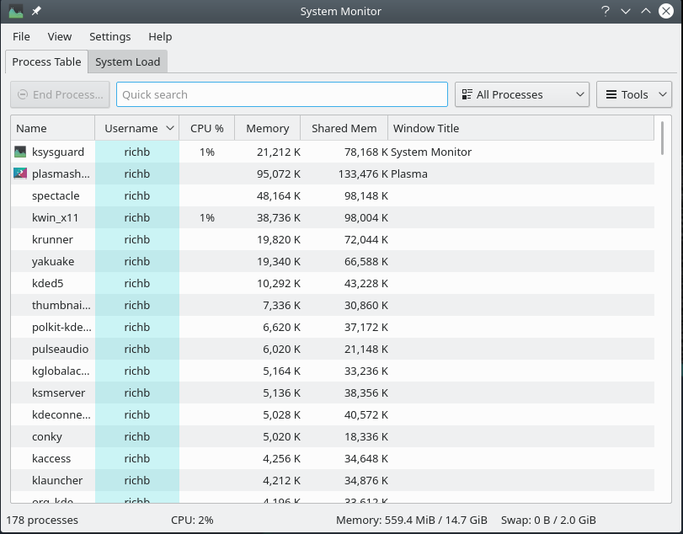 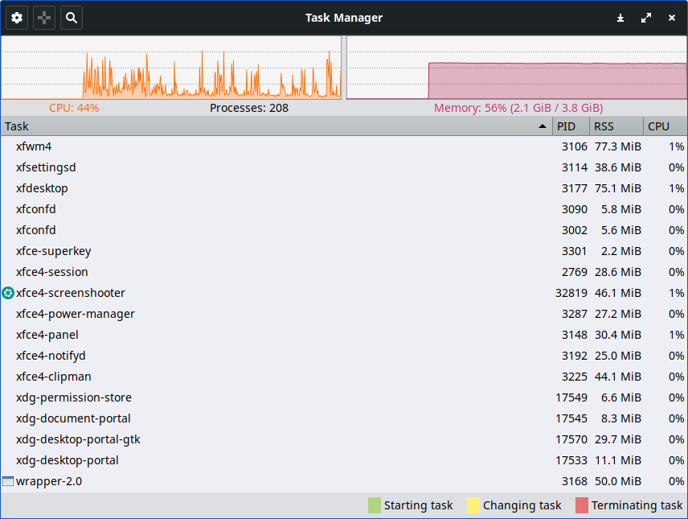

***Figure 4-14: Task Manager, ready to kill a process. TOP: KDE/plasma BOTTOM: Xfce***

### 4.7.6 Track performance

#### General

* GUI
  + Click Application Menu > System > System Profiler and Benchmark, where you can not only see a great many specifications but also run performance tests.
  + Many conkies show system performance; use Conky Manager to preview them for your needs and preferences. See Section 3.8.3.
  + Xfce plugins. Xfce 4.12 brings a number of plugins for monitoring the system that can be placed in the Panel, including Battery Monitor, CPU Frequency Monitor, CPU Graph, Disk Performance Monitor, Free Space Checker, Network Monitor, Sensor plugin, System Load Monitor, and Wavelan. They can all be installed with the metapackage **xfce4-goodies.** KDE/plasma has a similar set of panel and desktop widgets.

[Xfce4 Goodies home page](http://goodies.xfce.org/projects/panel-plugins/start)

* CLI
  + lm-sensors. This hardware health monitoring package is installed by default in MX Linux. Open a terminal, become root, and enter:

*sensors-detect*

Click Return to answer yes to all questions. When it has finished, you will be able to get detailed information about the readings of the sensors that are available on your system by opening a terminal and entering: *sensors*.

[Lm-sensors home page](https://wiki.archlinux.org/index.php/Lm_sensors)

#### Battery

Battery level is monitored by the Power Manager plugin on the Panel. A dedicated Panel plugin called *Battery Monitor* is also available by right-clicking the Panel > Panel > Add New Items ... KDE has a Battery Monitor panel widget installed by default.

### 4.7.7 Schedule tasks

* GUI
  + MX Job Scheduler, see 3.2.11.
  + Scheduled tasks (**gnome-schedule**). A very handy way to schedule system tasks without having to directly edit system files. [Gnome-schedule home page](http://gnome-schedule.sourceforge.net/).
  + KDE has a [Task Scheduler](https://userbase.kde.org/System_Settings/Task_Scheduler) with similar capabilities.

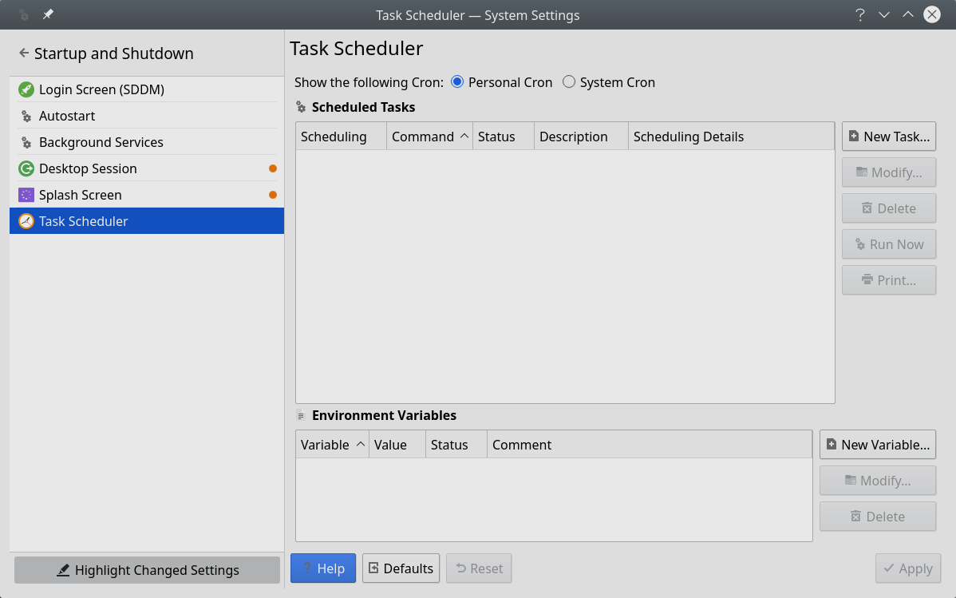

***Figure 4-15: Main screen of KDE’s Task Scheduler***

* CLI
  + You can edit **crontab**, a text file with a list of commands to be run at specified times.

[Crontab overview](https://mxlinux.org/wiki/system/crontab/)

[Easy crontab generator](http://crontab-generator.org/)

### 4.7.8 Correct time

Correct time setting is normally taken care of at Live boot or during the installation. If your clock time is always wrong, there are 4 possible issues:

* wrong timezone
* wrong selection of UTC versus local time
* BIOS clock set wrong
* time drift

These issues are most easily addressed by using MX Date & Time (Application Menu > System); for command line techniques, see [the MX/antiX Wiki](https://mxlinux.org/wiki/system/time-settings).

### 4.7.9 Show Key Lock

On many laptops there is no indicator light for the activation of the CapsLock or NumLock keys, which can be very annoying. To solve this with an onscreen notifier, install **indicator-keylock** from the repos.

## 4.8 Good practices

### 4.8.1 Backup

The most important practice is to [back up your data and configuration files](https://wiki.archlinux.org/index.php/Backup_programs) regularly, a process that is easy in MX Linux. It is highly recommended that you back up to a different drive than the one your data is on! The average user will find one of the following graphical tools convenient.

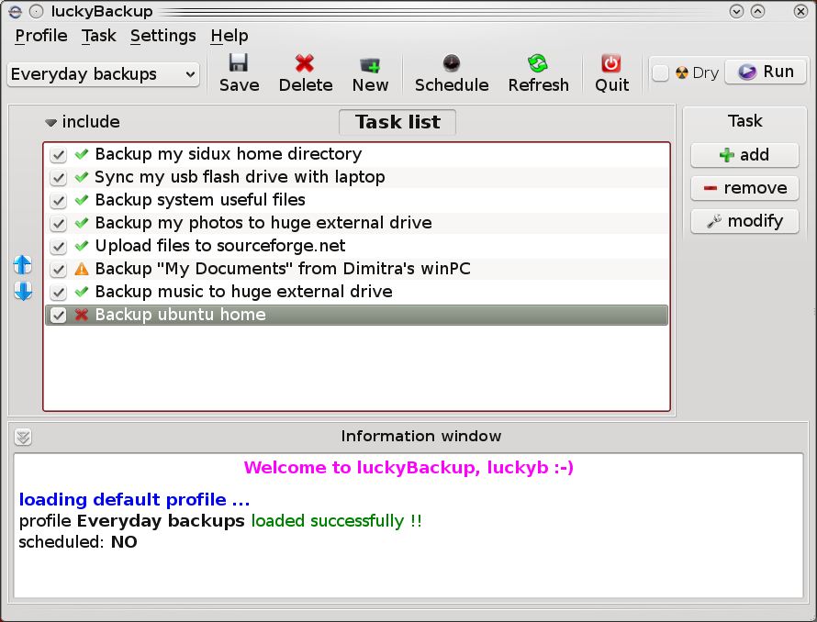

***Figure 4-16: Main screen of Lucky Backup***

* gRsync, a graphical frontend for [rsync](https://en.wikipedia.org/wiki/Rsync).

[Overview of gRsync](https://www.dedoimedo.com/computers/grsync.html)

* LuckyBackup. An easy program to back up and sync your files. Installed by default.

[LuckyBackup manual](http://luckybackup.sourceforge.net/manual.html)

* Déjà Dup. A simple but very effective backup tool.

[Déjà Dup home page](https://launchpad.net/deja-dup)

* BackInTime. A well-tested app available from MX Package Installer > MX Test Repo (preinstalled on MX KDE)
* Cloud service. There are many cloud services that can be used for backing up or synching your data. DropBox and Google Drive are probably the best known, but many others exist.
* Cloning. Create a complete image of the hard drive.
  + Clonezilla. Download Clonezilla Live from the [Clonezilla home page](http://clonezilla.org/), and then reboot into it.
  + Timeshift. Full system backup/restore; in the repos. [Timeshift home page](https://github.com/teejee2008/timeshift) includes a detailed overview and how-to.
  + Save the system to a live ISO (Section 6.6.3).
  + CLI tools. See the discussion in the [Arch Wiki: Cloning](https://wiki.archlinux.org/index.php/disk_cloning)
* CLI commands for doing backups (rsync, rdiff, cp, dd, tar, etc.).

#### Data

Make sure you back up your data, including documents, graphics, music, and mail. By default, most of this is stored in your /home directory; we recommend that if possible you have a separate data partition, best in an external data location.

#### Configuration files

Here is a list of items to consider for backup.

* /home. Holds most of the personal configuration files.
* /root. Holds the changes you have made as root.
* /etc/X11/xorg.conf. X configuration file, if there is one.
* The GRUB2 files /etc/grub.d/ and /etc/default/grub.

#### List of installed program packages

It’s also a good idea to save in your /home directory or in the cloud (Dropbox, Google Drive, etc.) a file that contains the list of programs that you have installed with Synaptic, apt-get or Gdebi. If in the future you need to reinstall, you can recover the names of the files for reinstallation.

A handy tool to list packages installed since the system was initially installed can be found by right-clicking on the **MX Updater** icon in the Notification Area > Apt History. A list of programs you installed via the apt system will appear that you can copy and paste into a document for storage and reference.

You can create an inventory of all packages on your system installed since installation by copying this long command and running it in a terminal:

dpkg -l | awk '/^[i|h]i/{ print $2 }' | grep -v -e ^lib[0-q\|s-z] -e ^libr[0-d\|f-z] -e ^libre[0-n\|p-z] -e -dev$ -e -dev: -e linux-image -e linux-headers | awk '{print $1" installed"}' | column -t > apps_installed.txt

That will create a text file in your home directory called “apps_installed.txt” that contains all the package names.

To reinstall ALL those packages at once: make sure that all needed repositories are enabled, then issue these commands one at a time:

*su*

*dpkg \SpecialChar nobreakdash\SpecialChar nobreakdashset-selections < apps_installed.txt*

*apt-get update*

*apt-get dselect-upgrade*

**NOTE**: this should not be attempted between MX releases based on different Debian versions (e.g., from MX-14.4 to MX-15 or MX-16)

There is a tool [**aptik**](https://mxlinux.org/wiki/other/application-migration-aptik)in the repos that can help if used with caution. It was developed for Ubuntu but will save a lot of effort in MX Linux as well, especially with respect to settings files that tend to be overlooked.

### 4.8.2 Disk maintenance

As a system ages, it often accumulates data that is no longer being used and gradually fills up the disk. Such problems can be alleviated by periodic use of MX Cleanup.

Let us look at an example. When her machine was slowing down, one user checked free space on the disk using *inxi -D* and was startled to see that the disk was 96% full. Clicking on the Run Disk Usage Analyzer button in MX Cleanup provided a good graphical analysis, and clicking on the big red segments revealed that the cache was bloated.

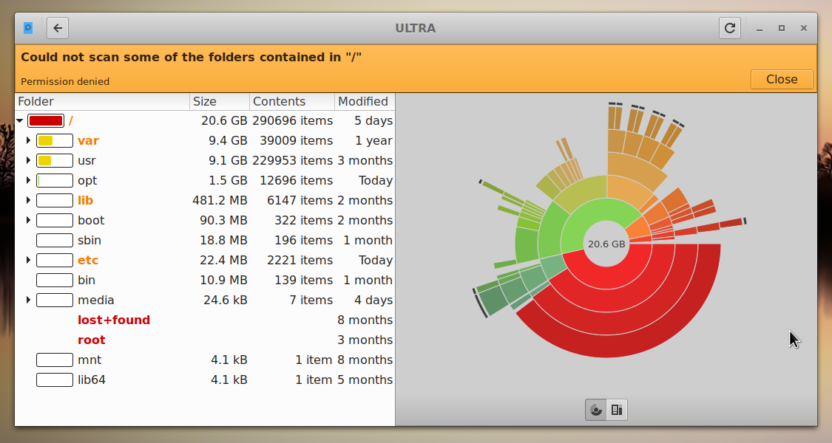

***Figure 4-17. Disk Usage Analyzer displaying a root directory almost full***

After it had been cleaned using MX User Manager, the percentage dropped to about 63% and the sluggishness was gone.

### 

***Figure 4-18. The results of clearing out the cache as represented by Disk Usage Analyzer***

#### Defragging

Users coming from Windows may wonder about the need to defrag the drive periodically. Defrag is not likely to be needed on the MX default ext4 file system but if it's almost full and hasn't got a contiguous area big enough to allocate your file, you'll end up with fragmentation. You can check the status if necessary with this command:

sudo e4defrag -c /

You will see after a few seconds a score and a simple statement about whether it needs defragmentation or not.

### 4.8.3 Error checking

Many error messages are written to the appropriate file in */var/log/* covering problems in applications, events, services and system.Some important ones include:

* */var/log/boot*
* */var/log/dmesg*
* */var/log/kern.log*
* */var/log/messages*
* */var/log/Xorg.0.log*

They are not always easy to read, but often worth looking at if you suspect a problem. You can look at them in a terminal by using the command *cat* followed by the location of the log you want to see.

## 4.9 Games

Browsing the extensive list of games available through Synaptic (click Sections > Games at the bottom of the left panel) or following the links below will bring up many other titles for your enjoyment.

The following list contains some examples to whet your appetite.

### 4.9.1 Adventure and Shooter Games

* Chromium B.S.U.: A fast paced, arcade-style, top-scrolling space shooter. Installed by default.

[Chromium B.S.U. home page](http://chromium-bsu.sourceforge.net/)

* Beneath A Steel Sky: A science-fiction thriller set in a bleak post-apocalyptic future.

[Beneath a Steel Sky home page](https://en.wikipedia.org/wiki/Beneath_a_Steel_Sky)

* Kq: A console-style role playing game, similar to Final Fantasy.

[Kq home page](http://kqlives.sourceforge.net/)

* Mars. “A ridiculous shooter.” Protect planet from your jealous neighbors!

[Mars home page](http://mars-game.sourceforge.net/?page_id=972)

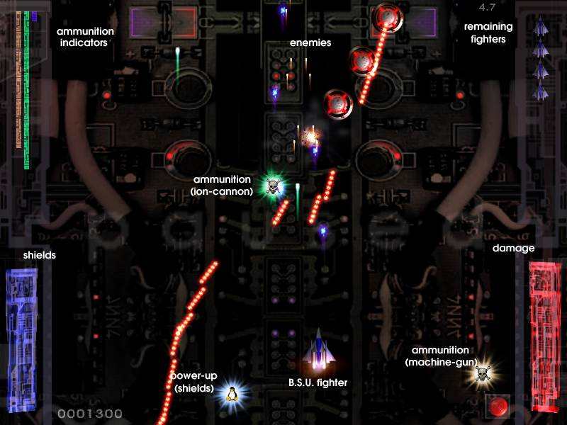

**Figure 4-19: Enemy warships on the attack in Chromium B.S.U**

### 4.9.2 Arcade Games

* Defendguin: A clone of Defender, where your mission is to defend little penguins.

[Defendguin home page](http://www.newbreedsoftware.com/defendguin)

* Frozen Bubble: Colored bubbles are frozen at the top of the playing screen. As the Ice Press descends, you must pop out groups of frozen bubbles before the Press reaches your shooter.

[Frozen Bubble home page](http://www.frozen-bubble.org/)

* Planet Penguin Racer: a fun racing game with your favorite penguin.
* [Tuxracer home page](http://tuxracer.sourceforge.net/)
* Ri-li: A toy train game.

[Ri-li home page](http://ri-li.sourceforge.net/)

* Supertux: A classic 2D jump’n’run side-scrolling game in a style similar to the original SuperMario games.

[Supertux home page](http://supertux.lethargik.org/)

* Supertuxkart: A much improved version of tuxkart.

[Supertuxcart home page](http://supertuxkart.sourceforge.net/)



***Figure 4-20: Ri-li train needs to turn soon***

### 4.9.3 Board Games

* Gottcode games: of the ones available, Peg-E (Peg solitaire game) installed by default.

[Gottcode home page](http://gottcode.org/)

* Mines (gnomines): A minesweeper game for 1 player.

[Mines home page](https://wiki.gnome.org/Apps/Mines)

* Do’SSi Zo’la: The goal of the basic Isola game is to block the opponent by destroying the squares which surround him.

[Do'SSi Zo'la home page](http://dossizola.sourceforge.net/)

* Gnuchess: A chess game.

[Gnuchess home page](http://www.gnu.org/software/chess)

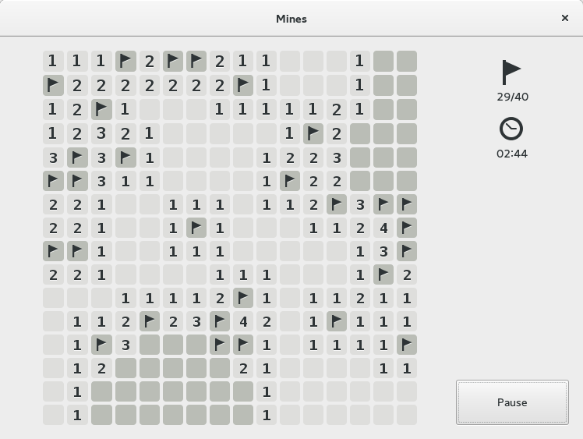

***Figure 4-21: High-tension moment in Mines.***

### 4.9.4 Card Games

Here are some fun card games available from the repos.

* Pysolfc: Over 1,000 solitaire games from a single application.

[Pysolfc home page](http://pysolfc.sourceforge.net/)

### 4.9.5 Desktop Fun

* Xpenguins. Penguins walk around your screen. Can be customized with other characters like Lemmings and Pooh Bear (need to allow programs to run in root window).

[Xpenguins home page](http://xpenguins.seul.org/)

* Oneko. A cat (neko) follows your cursor (the mouse) around the screen. Can be customized with a dog or other animal.

[Wikipedia: Neko](https://en.wikipedia.org/wiki/Neko_(software))

* Algodoo. This free game presents a 2D physics sandbox where you can play with physics like never before. The playful synergy of science and art is novel, and makes it as educational as it is entertaining.

[Algodoo home page](http://www.algodoo.com/)

* Xteddy. Puts a cute teddy on your desktop. Alternatively you can add your own image.

[Xteddy homepage](http://staffwww.itn.liu.se/~stegu/xteddy/index.html)

* Tuxpaint. A drawing program for kids of all ages.

[Tuxpaint home page](http://www.tuxpaint.org/)

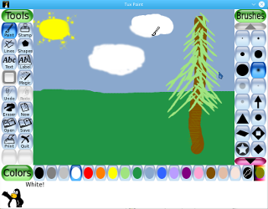

***Figure 4-22: Budding genius at work in Tuxpaint***

### 4.9.6 Children

* Three packages of games and educational applications are available from MX Package Installer.
* In addition, Scratch is a free programming language and online community where you can create your own interactive stories, games, and animations. MX Package Installer.

Scratch home page

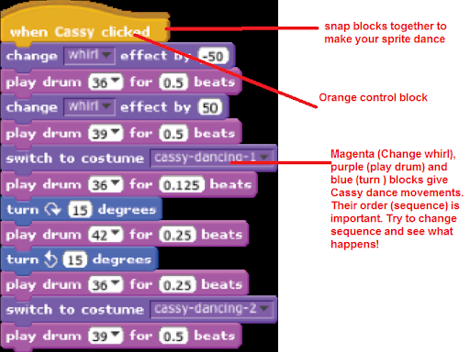

**Figure 4-23: Coding screen for Dance Party using Scratch**

### 4.9.7 Tactics & Strategy Games

* Freeciv: A clone of Sid Meyer’s Civilization© (version I), a turn-based multiplayer strategy game, in which each player becomes the leader of a stone age civilization, trying to gain ascendency as the ages progress.

[Freeciv home page](http://www.freeciv.org/)

* Lbreakout2: LBreakout2 is a breakout-style arcade game where you use your paddle to aim a ball at bricks until all bricks are destroyed. Many levels and surprises. Installed by default.

[Lgames home page](http://lgames.sourceforge.net/)

* Lincity: A clone of the original Simcity. You must build and maintain a city and keep its people satisfied so that your population grows.

[Lincity home page](http://lincity.sourceforge.net/)

* Battle for Wesnoth: A highly-rated turn-based strategy game with a fantasy theme. Build your army and fight to regain the throne.

[Battle for Wesnoth home page](http://www.wesnoth.org/)

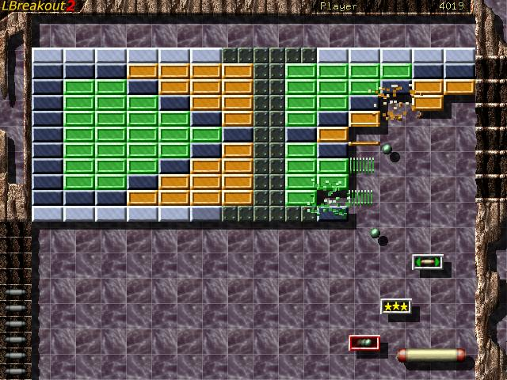

***Figure 4-24: Trying to break through the first wall in Lbreakout***

### 4.9.8 Windows games

A number of Windows games can be played in MX Linux by using a Windows emulator such as Cedega or DOSBox, or some may even run under Wine: see Section 6.1.

### 4.9.9 Game services

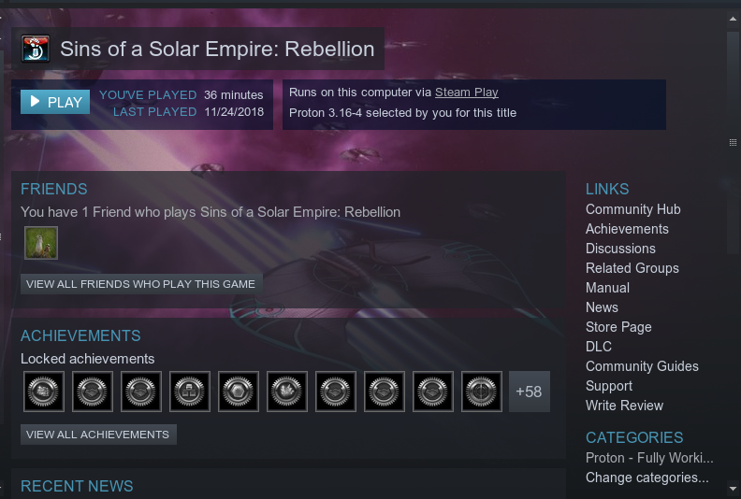

***Figure 4-25: Sins of a Solar Empire: Rebellion running on Steam with Proton***

There exist various collections and services for the user wishing to play games on MX Linux. Two of the best known are easily installable with MX Package Installer.

* PlayOnLinux. A graphical frontend for Wine (Section 6.1) that allows Linux users to easily install and use numerous games and apps designed to run with Microsoft® Windows®.

[PlayOnLinux homepage](https://www.playonlinux.com/en/).

* Steam. A proprietary digital distribution platform for purchasing and playing video games that provides installation and automatic updating of games. Includes Proton, a modified distribution of Wine.

[Steam homepage](https://store.steampowered.com/)

## 4.10 Google tools

### 4.10.1 Gmail

Gmail can be easily set up in Thunderbird following the prompts. It can also be easily accessed in any browser.

### 4.10.2 Google’s Contacts

Google’s Contacts can be linked into Thunderbird by using the add-on gContactSync.

[gContactSync home page](http://www.pirules.org/addons/gcontactsync/)

### 4.10.3 Gcal

Gcal can be set up on a tab in Thunderbird with the add-ons Lightning and Google Calendar Tab.

[Lightning calendar home page](https://www.mozilla.org/en-US/projects/calendar/)

### 4.10.4 Gtasks

Gtasks can be included in Thunderbird by ticking the Tasks entry of the calendar.

### 4.10.5 Google Earth

The easiest method of installing Google Earth is by using MX Package Installer, where it is in the “Misc” section.

There is also a manual method that may be useful in some installations.

* Install **googleearth.package** from the repos or directly from [the Google repo](https://www.google.co.uk/earth/download/gep/agree.html).
* Open a terminal and enter:

make-googleearth-package

* Once that is finished, become root and type:

dpkg -i googleearth*.deb

* An error message will appear on screen about dependency problems. Correct that by entering this last command (still as root):

apt-get -f install

Now finally Google Earth will appear in **Application Menu > Internet**.

### 4.10.6 Google Talk

There is a browser plugin called **google-talkplugin** available from [the Google repos](https://tools.google.com/dlpage/hangoutplugin) that allows you to make a voice or video call from your Gmail account to another Gmail user. It has been superseded by [Google Duo](https://duo.google.com/) that can be run directly from Gmail opened in a browser

### 4.10.7 Google Drive

Convenient tools providing local access to your GDrive account exist.

* A free simple app called [Odrive](https://www.omgubuntu.co.uk/2019/02/odrive-google-drive-linux-client) installs and works well.
* The proprietary cross-platform app [Insync](https://www.insynchq.com/google-drive-linux) allows selective syncing and installation on multiple computers.

## **4.11** Bugs, issues and requests

Bugs are errors in a computer program or system that produce incorrect results or abnormal behavior. “Requests” or "enhancements" are additions requested by users, either as new applications or new features for existing applications. MX Linux deals with these in the following manner:

* Bugs are managed by means of [the](http://bugs.mxlinux.org/) [MX and antiX Linux Bug Tracker](https://us-bz3.devzing.com/mx_antix/).
* Requests can be made with a post in the [Bugs and Request Forum](https://forum.mxlinux.org/viewforum.php?f=97), being careful to provide information about hardware, system and other details
* Devs as well as Community members will respond to those posts with questions, suggestions, etc.

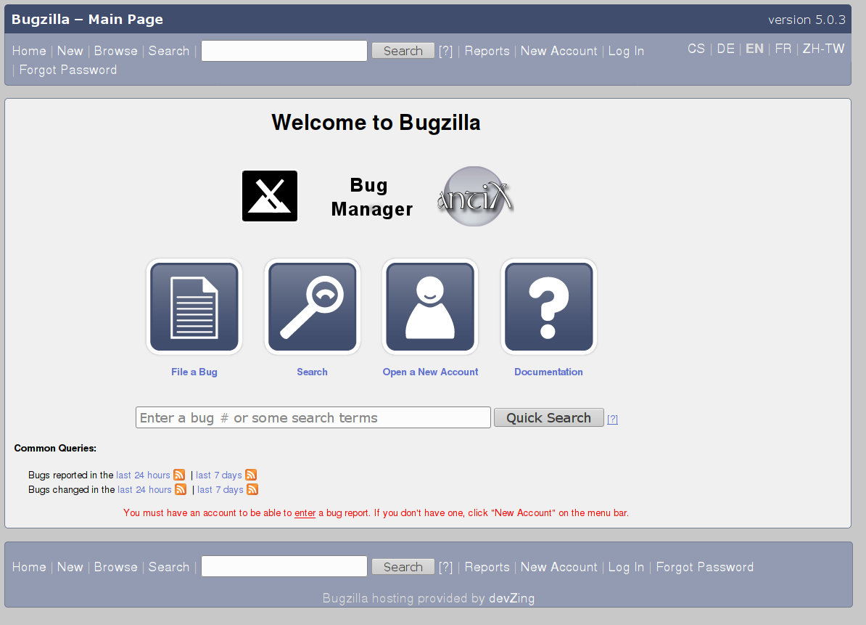

**Figure 4-26: dashboard of the bug manager**